ASSESSMENT BRIEF

Programme | BSc Cyber Security, BSc Computer Science, BEng Software Engineering, BSc Web Design and Development
Module Title | Software Development 3
Module Code | CMP020N201
Module Level | 5 | Assessment Type(s) | Practical Coursework:  This coursework contains 3 Sprints.
Word Length / Duration | N-A | % contribution to module mark | 100 Percent
Deadline (date & time) for Submission | Coursework:  Sprint 1:  24-October-2025  Sprint 2:  21-November-2025  Sprint 3:  7-January-2026 | Format/Location of submission | Format: Source code files and documentation.  Location: Submission Box on Moodle
Assessment Feedback date: | Coursework:  Sprint 1:  27-October-2025 to 07-November-2025  Sprint 2:  24-November-2025 to 05-December-2025  Sprint 3:  Week commencing 7-January-2026
Learning Outcomes  The assessments have been designed to provide you with an opportunity to demonstrate your achievement of the learning outcomes listed below.  LO1: Compare and contrast the procedural/functional approach and the object-oriented approach. Understand both as defining a matrix of operations and variants.  LO2: Write event handler for use in reactive systems, such as GUIs.  LO3: Construct models of the design of a simple software system that are appropriate for the paradigm used to design it.  LO4: Construct a simple user interface using a standard API.  Sprint 1 and Sprint 2:  By successfully completing this assessment, you will be able to achieve LO3. You will partially achieve LO1 by understanding object-oriented programming.  Sprint 3:  By successfully completing this assessment, you will be able to achieve LO2, and LO4. You will achieve LO1 through understanding procedural/functional approach and be able to define a matrix of operations and variants of object-oriented programming and procedural/functional approach. |  | Employability and Professional Skills  These assessments have been designed to provide you with an opportunity to demonstrate your achievement of the following skills which are critical in professional context and jobs.  The students will be able to widen their perception of programming approaches and paradigms. At the end of the module, students should have enough experience and exposure to programming languages and frameworks so they can use any tool they are required to. This is a fundamental capability for students as the tools they will use in the workplace are varied and liable to change often during their career. The programming languages and tools are introduced in weekly lab sessions and integrated into coursework.
Assessment Requirements
Overview
You will build a small application using Java.
The coursework should be delivered in 3 sprints. In each sprint, you will add new functionality and improve your code using the knowledge you will gain as the module progresses.

Planning and documentation are as important as working code. We are looking for a professional approach that considers readability, maintainability, conformance to standards, and correct operation. You will supply detailed documentation as well as code.
Please note that this is an individual piece of work. You will be asked to present your work in person to a lecturer and answer questions about your solution. You will have one practice assessment of sprint 1 (this won’t be graded – it’s just to help you check your progress) and two graded assessments. Sprint 2 will be marked in code reviews in class. You can only be marked for your sprint 2 if you have attended in-class assessment of sprint 1.

Task
Please choose one of the following projects to develop in your coursework. You should choose one project and stick to it throughout the module, fulfilling each of the sprint requirements in the context of your chosen project. Think carefully about which topic interests you most, as you will work on it throughout the term.

Your overall aim is to produce well-architected OOP code that shows an understanding of the problem domain, created using standard OOP techniques, and properly documented both within the code and in accompanying design documents. For each sprint, there will be well-defined basic requirements that must be met to achieve a pass, and advanced features that you can implement if you are aiming for higher marks.

We expect your code to conform to established coding standards as detailed here: https://google.github.io/styleguide/javaguide.html

Projects
SpareB&B
Users can book different kinds of accommodation. You can make any kind of accommodation available, for example, flats, hotels, luxury villas, or sofas. Your accommodations may have different facilities, such as kitchens or washing machines.
ZipAbout
Users can rent shared lightweight electric transport vehicles – bikes, scooters, skateboards, segway’s and other vehicles, perhaps yet to be invented. For some vehicles, users will need equipment such as helmets, kneepads, or gloves to use them.
LibraryOfStuff
Users can borrow all kinds of items - tools, sewing machines, phone chargers, bicycle pumps – little things we often need but can’t lay our hands on. Items can be categorized by the part of the home in which they are usually used: kitchen, garden, workshop, or ‘out and about’.

Sprint 1 – Basic Classes -
FORMATIVE assessment in lab sessions:
Submission deadline: 24-October-2025

- Consider the objects that can be booked, rented, or borrowed in your application. Identify their methods and properties.
- Use the OOP principles of Abstraction, Encapsulation, Inheritance, and Polymorphism to design your classes
- Create a class diagram showing the relationships between your classes.
- Write well-documented Java code to implement your classes. Minimum requirements should be:
  - a constructor
  - some properties
  - a print () method which gives some user-friendly output.
- Provide a Main class and main method that you can run in the console, in which:
  - At least 3 objects of different types are created in your code
  - A user-friendly listing of the objects can be printed to the console
- For those aiming for higher marks, also consider the additional information, e.g., facilities, equipment, and hobbies. Consider how composition can be used to model these in your system. Add them to your class diagram and code.

If you are seeking comprehensive feedback on your project activities, then please submit sprint 1 no later than 27-October-2025. Please hand in your work in Moodle and seek feedback during the week 5 and 6 lab sessions.

Sprint 2:
Booking functionality
Submission Deadline: 21-November-2025
50% of marks

Implement a booking system for your chosen project in Java. You do not need to implement booking for specific dates or durations, but it should be possible for a user to book and release items. Once an item is booked, it should not be available for booking by any other user.
NOTE:
You do not have to capture any user input at this stage of development.
Basic requirements
- Provide a set of user stories to cover your provided functionality
- Provide a class diagram showing the relevant classes and relationships.
- Your design and code should incorporate the sprint 1 requirements above, plus basic booking functionality.
- Each class containing at least 3 properties/attributes and 3 methods.
- Provide a Main class/method in which at minimum:
- At least 3 objects of different types are created directly in your code.
- At least 3 users are created directly in your code.
- In code, show that a booking can be made of an item by a user.
- Show in your code that if another user tries to book the same item, they are politely informed that the item is unavailable.
- User-friendly output can be printed showing correct information about items and the booking status at any particular time.

Advanced requirements

Basic requirements plus...

- Your design incorporates the additional information, e.g., Facilities, equipment, and hobbies for bookable items
- Include at least one design pattern, accompanied by a short explanation of how it has been implemented, and/or
- Devise a feature of your own choice that demonstrates your deeper understanding of design patterns. Perhaps by rewarding your application users in some way with loyalty points or a random prize draw, or perhaps by adding features to your application, such as managing cleaning or maintenance, or providing output in different formats (these are just examples).

Sprint 3 - GUI development

Submission Deadline: 7-January 2026
50% of marks
Assessment based on demo and viva will be held in week 13.
Create and document a GUI for your application using JavaFX.

Basic requirements
Documentation

- Provide a schematic ‘wireframe’ that provides the specification for your GUI
- Provide a set of user stories and class diagrams that document the provided functionality. Provide screenshots of your finished application.
- Write a conclusion to your documentation in which you identify the programming paradigms that you have used to create your application, e.g., object-oriented, declarative, functional, and describe why each is suitable for different tasks.
Code

- Implement basic button and list functionalities taught in class with some original design and formatting.
- Use the classes you have created in sprint 2 to create some basic functionality where you list bookable items.

Advanced requirements

- Use the classes you have created in sprint 2, including your design patterns, to implement the listing and selection of items, and provide feedback to the user. You may implement additional features of your choice.
- Use Java streams to implement at least one part of your application
- Ensure that these additional requirements are covered in your documentation.

Marking scheme/ criteria

Sprint 2
Basic requirements (3rd – 2.2)

- Design conforms to OOP principles
- Code runs correctly
- The class diagram is supplied and is correct
- Coding standards adhered to
- Inheritance implemented correctly
- Encapsulation implemented correctly.

Advanced features (2.1 and above)

- Association/aggregation used.
- Design patterns used.
- Additional features implemented.
- Excellent coding standards and documentation.

Sprint 3
Basic requirements (3rd – 2.2)

- A button that can respond to a click.
- Basic GUI design.
- Use of classes from sprint 1.
- List at least three bookable items displayed in the GUI generated by your sprint Java OOP code.
- Coding standards implemented.
- All required elements of the documentation are supplied, and the documentation. is accurate, and the document is well structured.
- A basic understanding of different programming paradigms is demonstrated in the conclusion.
Advanced requirements (2.1 and above)

The above plus...
- User can select a bookable item and an action is performed.
- Advanced features of your choice.
- Excellent use of coding standards.
- Excellent, accurate and complete documentation.
- Use of functional programming styles in at least one place in your code.
- Insightful and advanced understanding of different programming paradigms is demonstrated in the conclusion.

Marking Criteria
The marking criteria is given in rubrics for courseworks:
Sprint 2:
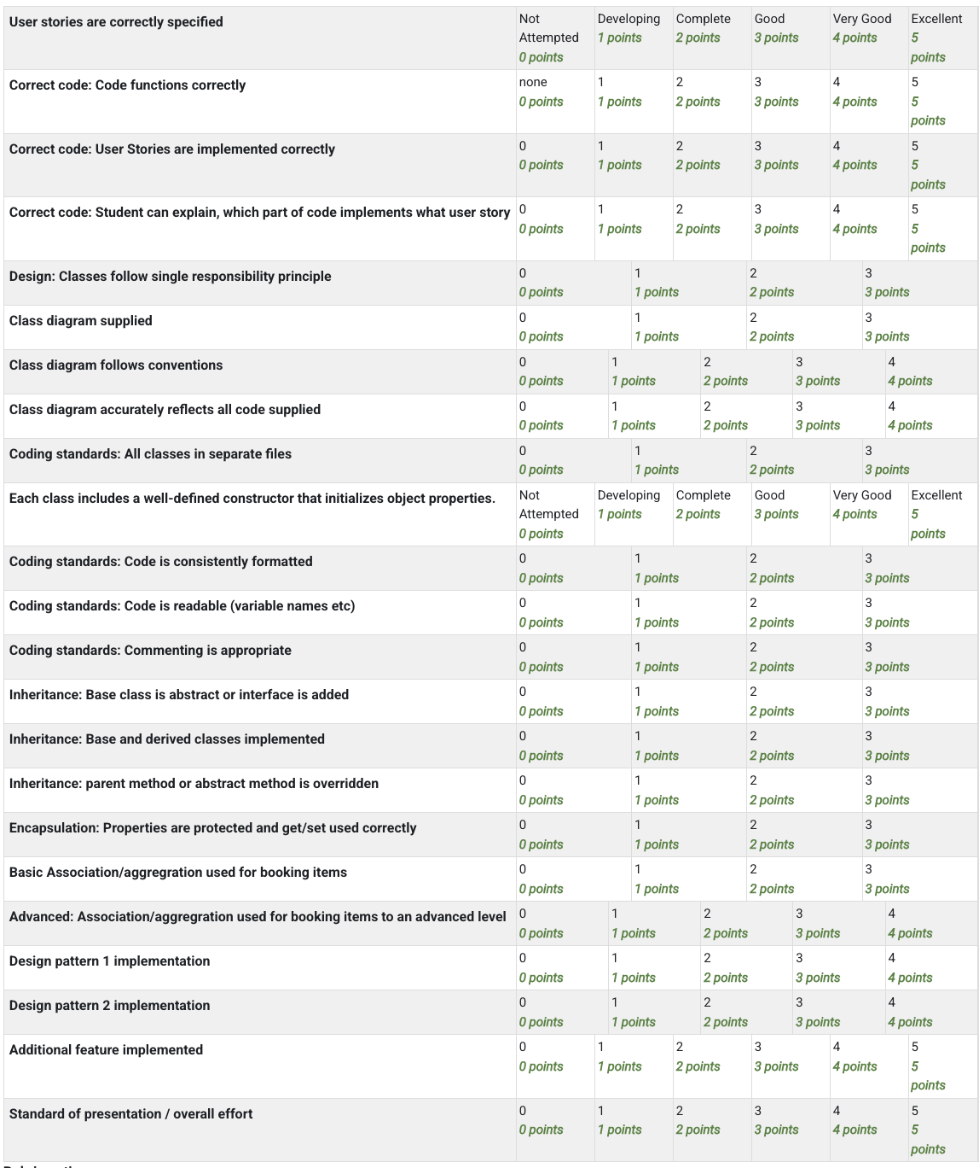
Sprint 3:
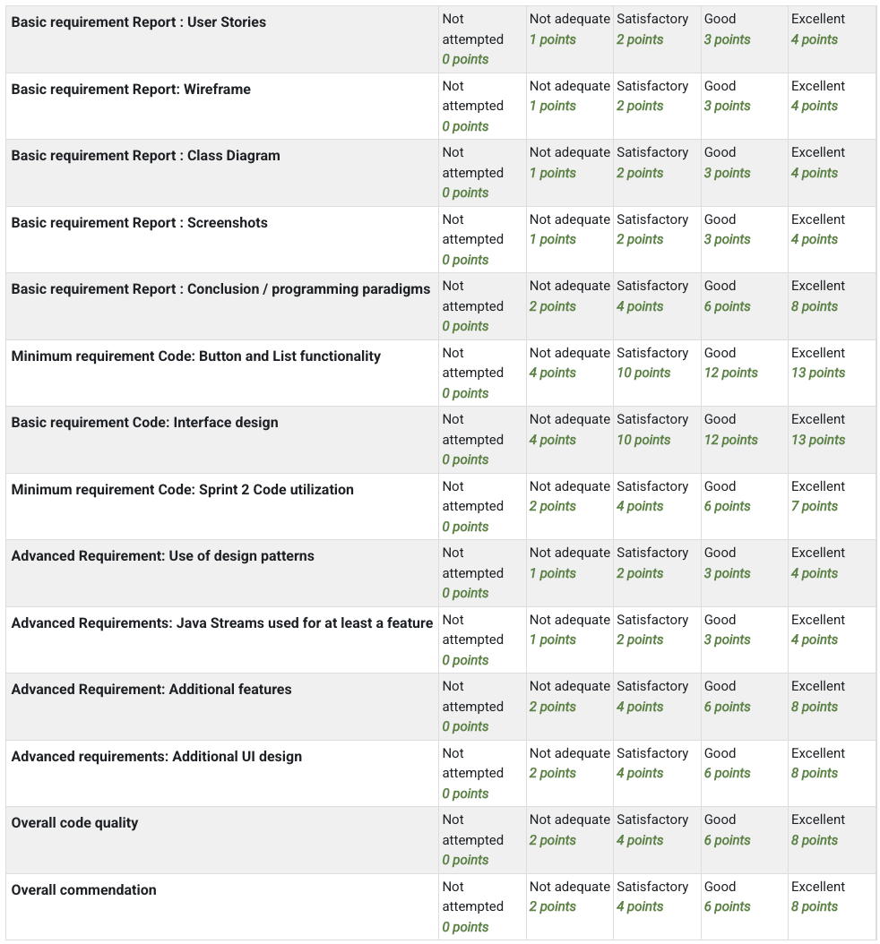
Assessment Success Guidance

How to Achieve Maximum Success
To perform strongly in this assessment, go beyond simply meeting the minimum requirements of each sprint. Focus on:
- Quality of Code
  - Follow Object-Oriented Programming (OOP) principles (abstraction, encapsulation, inheritance, polymorphism) consistently.
  - Apply coding standards (Google Java Style Guide) to improve readability, maintainability, and professional presentation.
  - Use composition and association appropriately in your class design where relationships exist beyond inheritance.
- Advanced Features
  - For higher marks, integrate design patterns (e.g., Singleton, Observer, Factory) and explain their relevance.
  - Add value-added functionality such as loyalty schemes, maintenance tracking, or different output formats.
  - Leverage Java Streams or functional programming where relevant, especially in Sprint 3.
- Documentation & Presentation
  - Provide detailed class diagrams, user stories, and wireframes that accurately reflect your implementation.
  - Write clear, professional documentation explaining your design decisions and how they enhance usability and maintainability.
  - In your conclusion, show a critical understanding of programming paradigms (OO, functional, declarative) and justify why they suit particular tasks.
- Professional Approach
  - Manage your project across sprints, showing progress and refinement.
  - Use consistent naming conventions, comments, and Javadoc to make your code professional.
  - Be prepared to present and defend your code in person during code reviews.

Exemplar Work & Resources
- Java Coding Standards (Google Style Guide):
https://google.github.io/styleguide/javaguide.html
- Academic Integrity Guidance (to avoid plagiarism/collusion):
https://roehampton.libwizard.com/f/academic_integrity
- JavaFX Documentation & Tutorials:
https://openjfx.io/
- UML Class Diagram Examples:
https://www.uml-diagrams.org/class-diagrams-overview.html
- Design Patterns in Java:
https://refactoring.guru/design-patterns/java
- First four weeks lecture slides and video lectures provide ample examples of user stories, object-oriented programming and class diagram concepts and how to create class diagram components.

Links to Key Themes
- Employability: The coursework project mirrors real-world software development processes: sprint-based development, code reviews, professional documentation, and adherence to coding standards. These practices prepare you for teamwork and industry-level expectations.
- Internationalisation: Applications like SpareB&B or ZipAbout can be extended to global contexts (e.g., multi-language support, international item listings), encouraging you to think about scalable and inclusive design.
- Sustainability – Projects like ZipAbout (shared e-transport) and LibraryOfStuff (borrowing instead of buying) directly address sustainable consumption and resource sharing, reflecting the UN’s sustainability goals.
Assessment Guidance Support and Formative Feedback
The coursework preparation guidelines and assessment schedule is already provided on Moodle. Further information about upcoming assessment guidance (e.g., lectures, signpost to information on Moodle etc) and opportunities where students can receive formative feedback will be provided through announcements on Moodle.
Contact for Queries/ who you can contact for further information or queries
The module homepage provides information about lecturers’ office hours and includes an online booking system for arranging meetings.

Ethical Requirements
This assessment does not require students to handle real-world personal data, confidential information, or sensitive organisational materials. All development work is carried out in a simulated academic environment, and projects are self-contained and for educational purposes only.
- Confidentiality and Anonymity
  - Any example data (e.g., names of users, booking records, or borrowed items) should be fictitious or anonymised.
  - Code demonstrations and viva assessments will remain confidential between the student and teaching staff.
- Academic and Professional Standards
  - All submissions must comply with academic integrity requirements (no plagiarism, collusion, or code sharing without attribution).
  - Referencing and acknowledgement of third-party resources (e.g., tutorials, libraries, frameworks) must follow university guidance.
  - Students are expected to follow professional coding standards (e.g., Google Java Style Guide) and conduct themselves in line with good software engineering practice.
- Legal and Organisational Considerations
  - The assessment must comply with UK copyright law and university regulations on academic work.
  - Students must not include or distribute copyrighted material without permission.
  - No collection, processing, or storage of real personal data is permitted.
- Ethical Approval
  - As this is a classroom-based, individual programming project with fictitious scenarios, formal ethical approval is not required.
  - If a student wishes to extend their project to include real user data or deploy it beyond the classroom context, they must seek prior ethical approval from the university’s ethics committee and BCS code of Conduct.

Use of Artificial Intelligence (AI)
ACADEMIC MISCONDUCT: Your submission for this coursework will be scrutinized for plagiarism, collusion, and other forms of academic misconduct. Please ensure that the work that you submit is your own and that you have cited and referenced appropriately, to avoid having to attend an academic misconduct hearing. You can find more information about academic integrity and how to mitigate plagiarism here: https://roehampton.libwizard.com/f/academic_integrity

- The assessment is designed so that the use of AI during the assessment is possible. You must acknowledge any use of AI and appropriately cite all AI generated outputs. Please make sure you read and understand the assessment guidelines and ask your Module Leader if you have any questions. You can find the guidance on the use of AI here.

Understanding Your Work
Do not submit any code, diagrams, or documentation that you cannot explain. During the viva/oral examination, you will be asked to discuss and justify your design choices, implementation, and testing. If you include a single line of code or design element that you do not understand, it will be treated as passing off someone else’s work (including that generated by AI) as your own. This constitutes academic misconduct. Penalties may include receiving a zero for this assessment component and being reported under the University’s Academic Misconduct procedures. Academic misconduct has also been shown to negatively impact students’ employment opportunities.
Generative AI
You may use Generative AI responsibly and ethically as part of your learning process. AI tools can help you clarify concepts, refine your understanding, and explore alternative solutions but they should augment, not replace, your own thinking. Treat AI as you would a supportive lecturer:
- Ask it to explain concepts in different ways (e.g., visual, example-driven).
- Use it to check your understanding by asking for alternative explanations or coding feedback.
- Do not ask AI to simply generate full solutions for you, this undermines your learning and will be evident in your code review and viva examination.
Example AI Prompts for Learning
- “Act as a Computer Science lecturer. I am developing a booking system in Java. Can you explain how to apply polymorphism in this context?”
- “Please show me a UML class diagram example for inheritance with accommodation types.”
- “I’m unsure how to implement a simple booking release function. Can you explain the logic step by step?”
- “Please review my Java method [paste method] and suggest improvements for readability and efficiency.”
Grading and Oral Examination
Marks are awarded not only for working programs and complete documentation (e.g., class diagrams, wireframes, user stories) but also for your ability to:
- Justify your design decisions.
- Demonstrate efficiency, simplicity, and creativity in your solutions.
- Apply good coding style and professional standards.
Your oral examination (viva) will be used to confirm your understanding of the code you have written and to assess your ability to explain, adapt, and improve it. The viva is part of the marking process, in line with the assessment rubrics provided.

Referencing
The resources used in the coursework must be cited using the IEEE reference style guidelines available at: https://journals.ieeeauthorcenter.ieee.org/wp-content/uploads/sites/7/IEEE_Reference_Guide.pdf
Mitigating circumstances/late penalties
Sometimes circumstances outside of your control may affect your studies and might prevent you from submitting work on time or attending an exam.
The University offers the ability for students to request additional time to complete an assessment or to defer an examination to a later date. If you are finding yourself in such a situation, please speak to your Academic Guidance Tutor, the Roehampton Student Union (RSU) or someone in the Wellbeing team first, who can support you. Further details can be found on the mitigating circumstances portal.
If you do not apply for or are not approved for Mitigating Circumstances, late penalties will apply. If work is submitted up to 14 days late, the mark will be capped at 40%; if it is over 14 days late, it will not be marked.
Resubmissions and Reassessment
If you are required to resubmit this assessment or take part in reassessment, you will be notified via Moodle and your student email. Please ensure you check both regularly. Any reassessment tasks will follow the same learning outcomes and criteria.
Submission Checklist
Before you submit, ask yourself:
- Have I fully answered the assessment brief?
- Have I met the word count and formatting requirements?
- Is my referencing complete and accurate?
- Have I declared any AI use honestly?
- Have I proofread my work?
- Am I submitting through the correct platform before the deadline?

